HSE West Online Payslips User Guide

Logging In

To ‘Sign In’ enter your 8 digit User ID and Password.

Please note your User ID is your Personnel Number this is located in your Welcome email when you first register and if you have a letter at the end of your personnel number this has to be entered as a higher case
Your Password and User ID will be supplied by email following successful registration. If you are using webmail such as Gmail or Yahoo please remember to check the Spam/Junk folders as automated emails are often sent to these folders. Webmail account access may be blocked when being accessed from within the HSE network.
The password is 4 characters in length. If you are copying from your email and pasting, it will often include an extra space at the end. If you see 5 dots when you paste into the password box, delete the last dot. If you are typing the password in please bear in mind that it is case sensitive; you will need to enter the password exactly as it appears on your Welcome mail, including any upper/lower case letters or numbers.
Sign- In
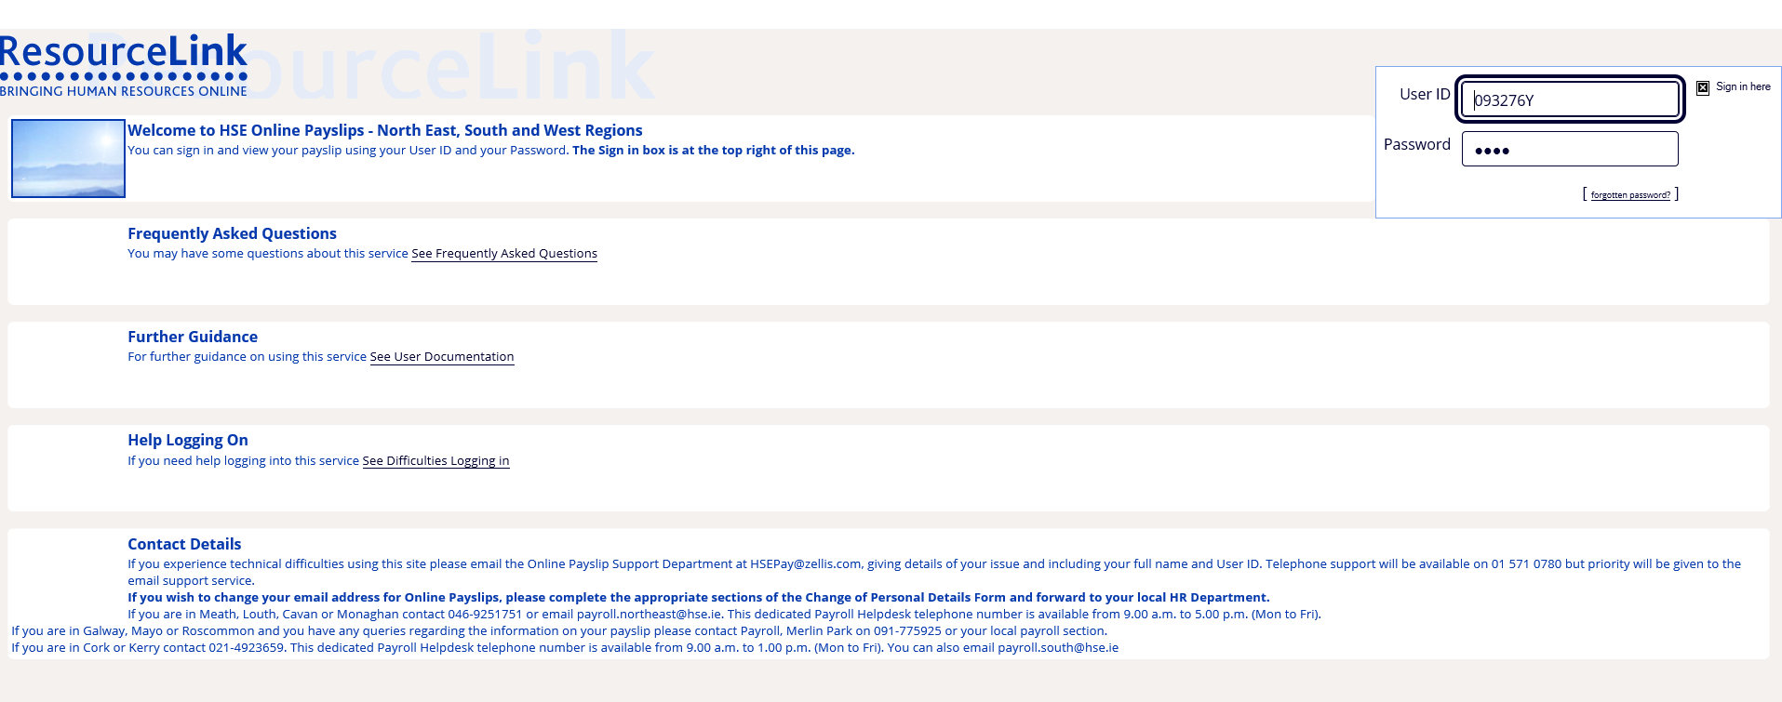

Contact Details

If you are unable to access the registration link or experience technical difficulties using this site please email the Online Payslip Support Department at HSEPay@Zellis.com, giving details of your issue and including your full name and User ID. Telephone support will be available on 01-5710 780, but priority will be given to the email support service.

If you are in Galway, Mayo or Roscommon and you have queries regarding the information on your payslip please contact the Payroll Helpdesk on 091-775925 or your local payroll section.

If you wish to change your email address for Online Payslips, please complete the appropriate sections of the change of Personal Details Form HR104 and forward to your local HR department.

On initial login you will also be asked to provide your PPS Number as part of the security validation process. Click on [Verify my details] to continue.

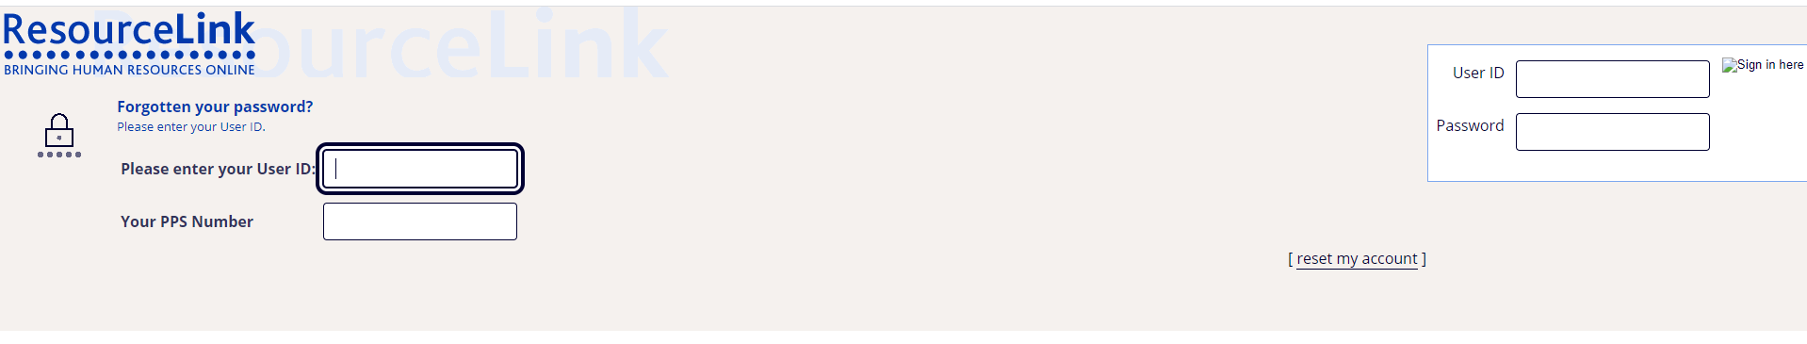

You will then be asked to set the answers to three security validation questions. You will be asked to provide the answer to one of these questions on each subsequent login as well as when resetting your password

Click on [Set my user questions] to continue

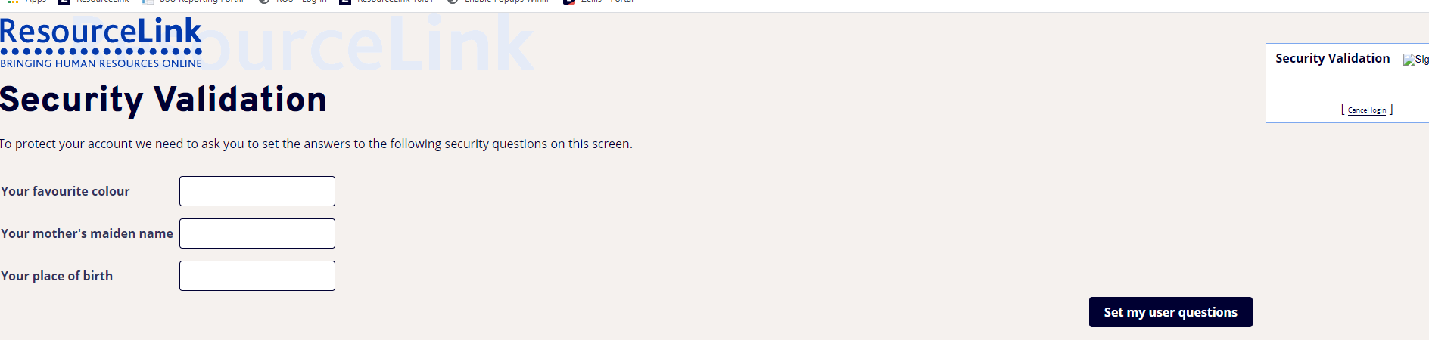

Once your questions have been set you must change your password, the new password must be entered and confirmed. The screen contains the valid format instructions.

Please note the old password here is the one that was provided in your welcome email.

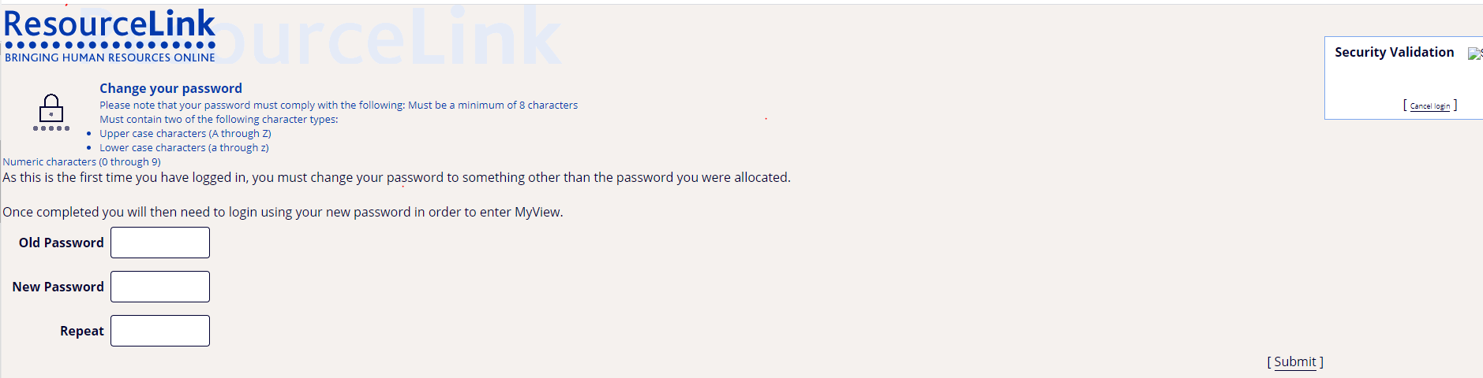

Clicking on [Submit] will bring you to the next screen

The following message confirms that the password change is complete.
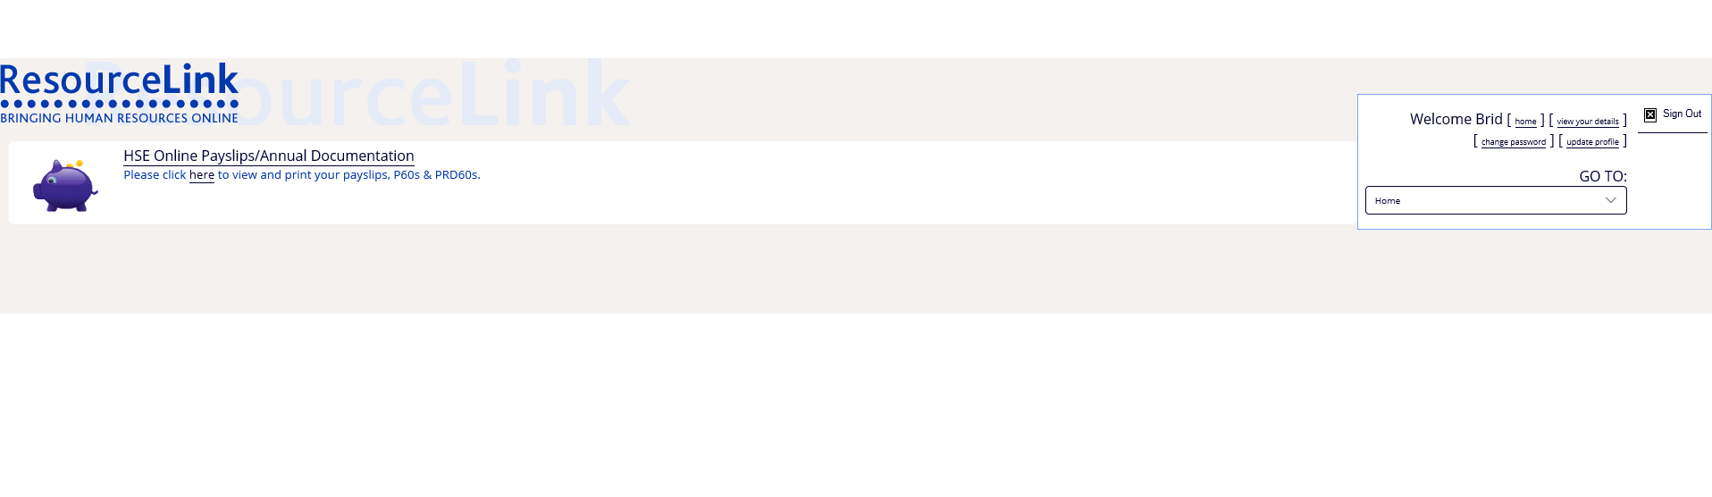

View your Payslip
The HSE Online Payslips screen will appear.

When you click on ‘here’ you are brought into the payslip selection screen.
You can then select which payslip you wish to view by clicking on the payslip date.
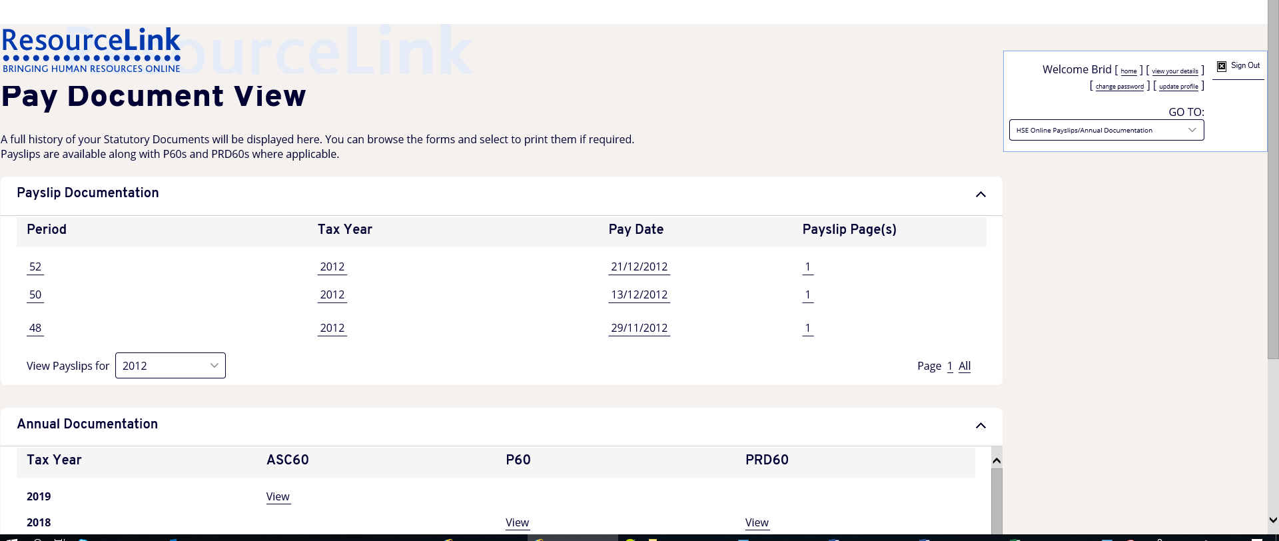

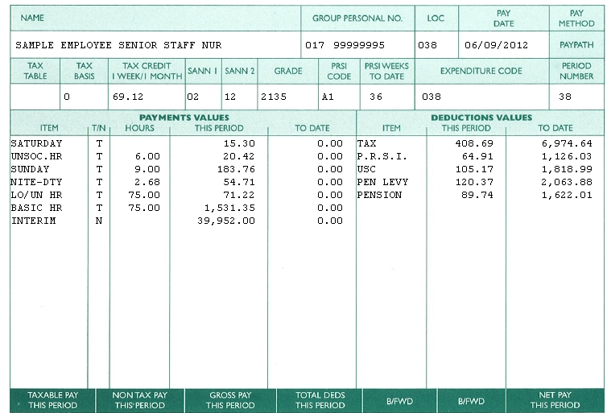
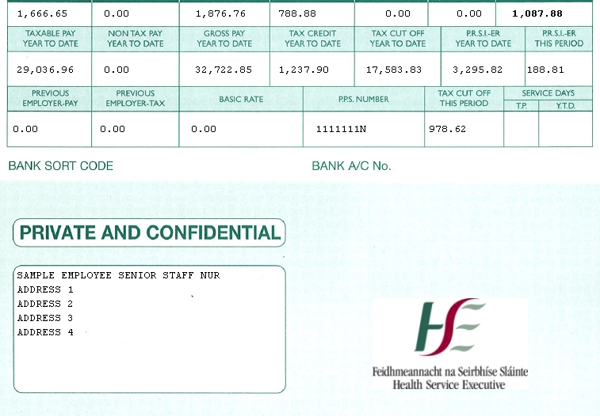

Requesting a new password

Using the ‘Forgotten Password’ link

This link allows you to request a password reset in the event that you cannot remember your existing password.

The first step is to click on the ‘forgotten password’ link

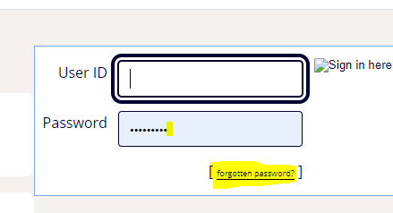

This brings up the Forgotten your Password page where you are prompted for your User ID and presented with one of your previously set security validation questions.

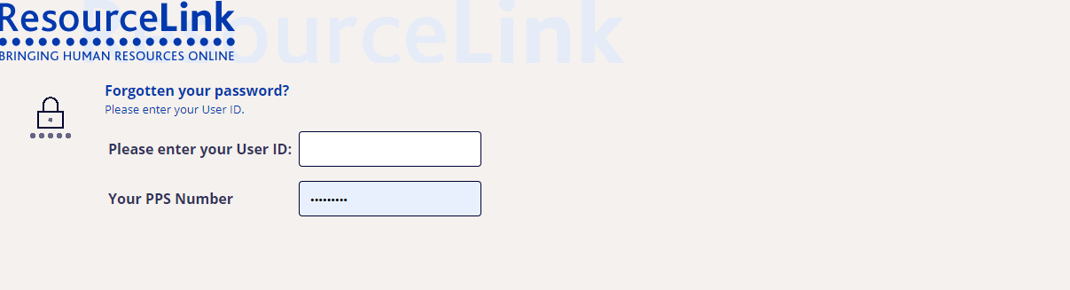

Click on [reset my account] link.

The following screen is displayed if you have entered incorrect details:

Top of Form
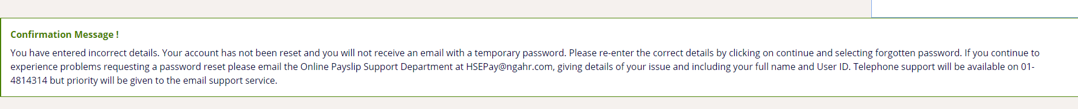
Bottom of Form
STOP

If the correct details have been supplied the following confirmation page will be displayed:
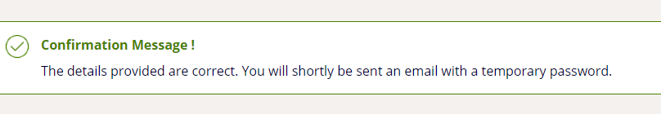

An email is generated and sent to your email account.

The email contains a temporary password and instructions for logging in:

From: <payslips@hse.ie>
Date: 13 November 2019 at 09:12:01 GMT
To: User@hse.ie

Subject: MyView Employee Self Service Forgotten Password
Dear User name,
Your password has been reset. In order to access this service you will need your User ID and Password.
Your User ID is 12345678
Your initial password is Gh74
As an initial security validation when you first login you will be asked your PPS Number. You will then be asked to create a number of additional security questions and to change your password. One of these additional security questions will be presented on each subsequent login.
To login now and view your payslips online please click on the following link.
https://onlinepayslipsrl.hse.ie/live/Portal/
Please do not reply to this email. Replies to this email will not be responded to or read. If you have any questions please visit the FAQs section on our website.
Kind Regards
System Administrator

You can then log in using the temporary password

On successful login you will be asked for your PPS number. Click on [Verify my details] to continue

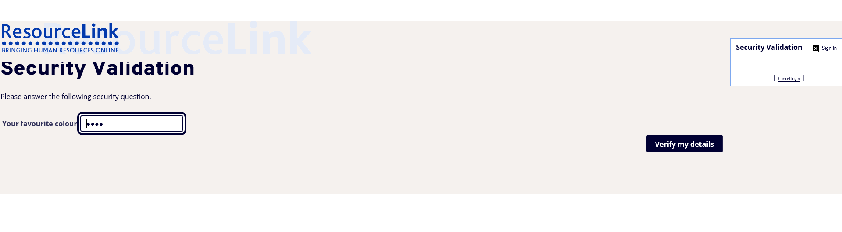

You will then be asked to set the answers to your security validation questions. On subsequent logins one of these questions will be asked and the answer must match the answer provided here

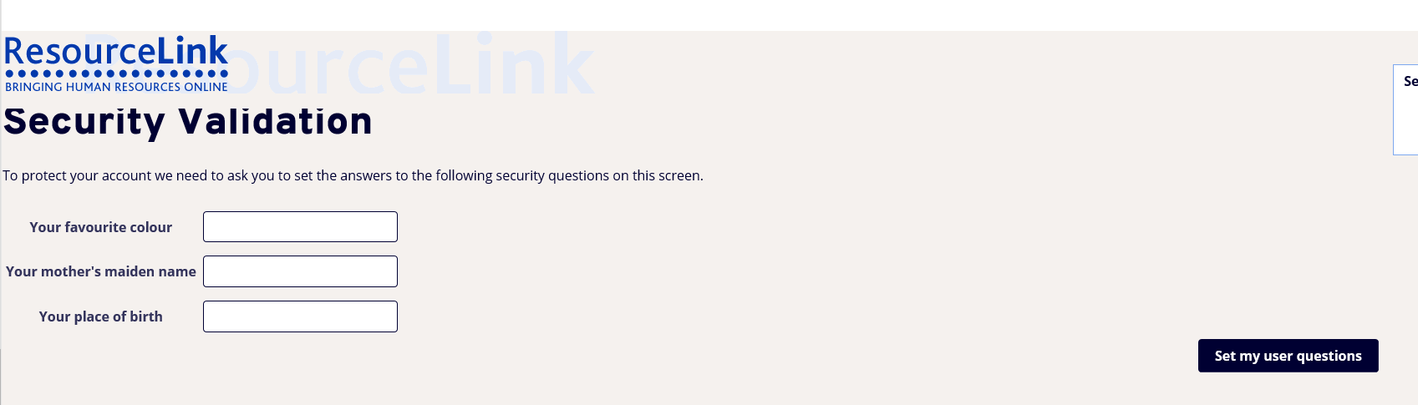

Click on [Set my user questions] to continue

Once these questions have been set you must change your password by entering your old password (just to note your old password is the password received when your password was re-set) followed by your new password which you must then confirm. The screen contains the valid format instructions.

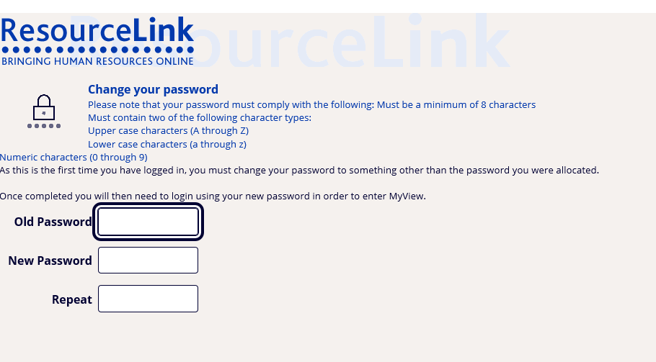
Clicking on [Submit] will bring you to the next screen

The following appears below and this confirms that the password change is complete.

Printing

Payslips can be printed by selecting print at the bottom right hand corner of the payslip

Can I remove the header and footer that outputs when I print my online payslip?
Yes this output can be adjusted via your browser by clicking on File and selecting Page Setup. You can then turn off the footer and header options.

Supported Internet Browsers for printing: Internet Explorer V7, V8, V9, Mozilla Firefox V3.5x, V3.6x, V6

Internet Browser not supported for printing: Google Chrome
Recommended settings for printing:
Internet Explorer
1. Open Internet Explorer
2. Click on the File option and then on Page Setup.

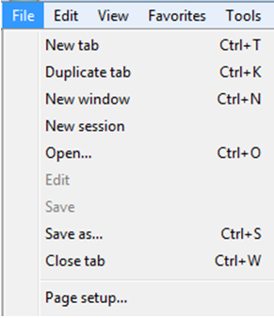

3. Ensure the following options are selected: Portrait, Enable Shrink to Fit
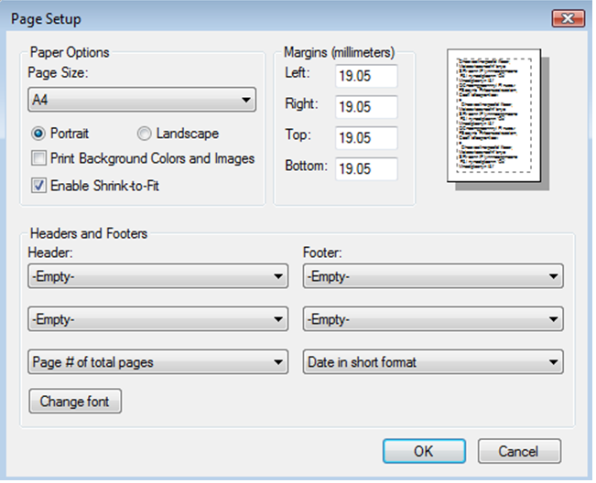
Mozilla/Firefox
1. Open Firefox:
2. Click on the Firefox option on the top left of the browser window.
3. Click on Print, Page Setup
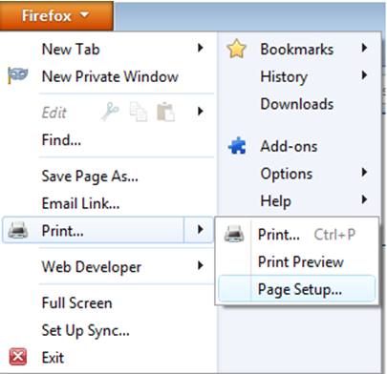

4. Ensure the following options are selected:
Portrait, Shrink to fit Page Width (the print size can be reduced further if required by deselecting Shrink to Fit and entering a percentage in the Scale box e.g. 80)

Other Links

Home – Clicking on the ‘Home’ link the following screen appears

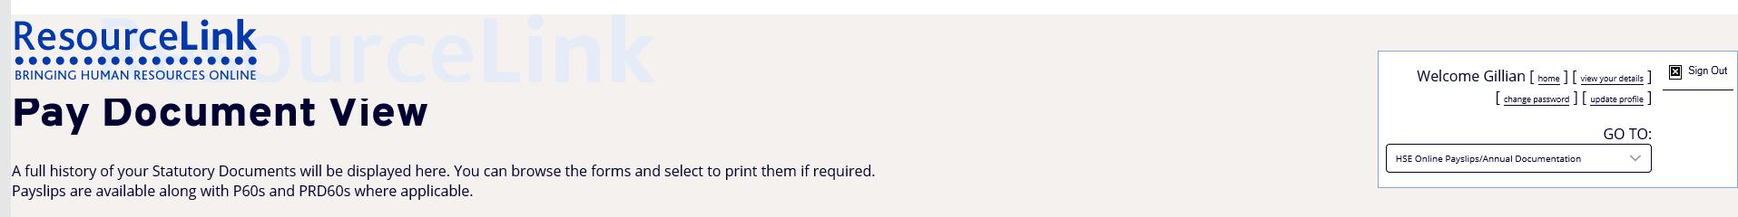

View your details – Clicking on the ‘View your details’ link the following screen appears

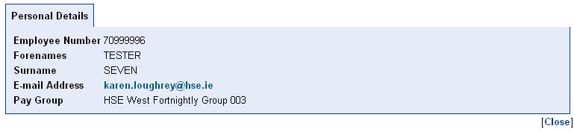

Change Password – Clicking on the ‘change password’ link allows you to change your password

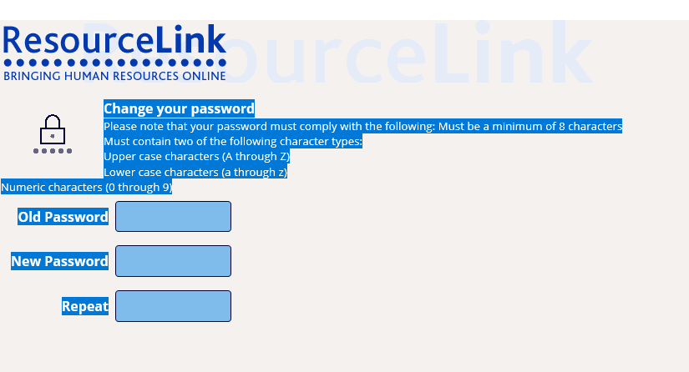

Update Profile – Clicking on the ‘update profile’ link allows you to reset the answers to your security validation questions
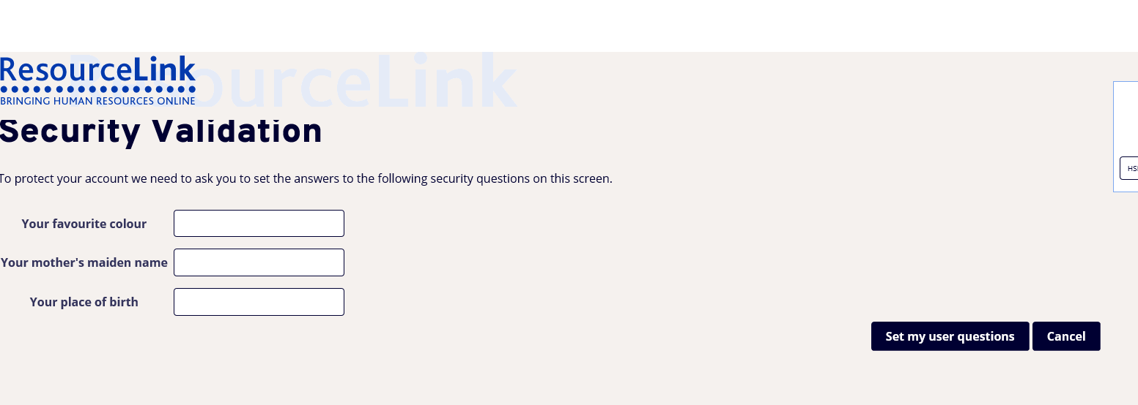

Need further help?

If you are still experiencing problems logging in, please email the Online Payslip
Support Department at HSEPay@Zellis.com, giving details of your issue and
including your full name and User ID. Telephone support will be available on 01-5710780 but priority will be given to the email support service.

